
ذ
REPUBLIC OF YEMEN
SANA'A UNIVERSITY
FACULTY OF ENGINEERING
MECHATRONICS ENGINEERING DEPARTMENT



Mechanical Structure Design and Static Analysis Report
Done by:
Ehab ALQubati-202174125
Supervised by:
Dr.Eng.

Title
Static Structural Analysis and Design Evaluation of a Welded Mechanical Support Frame

1. Introduction
This project presents the mechanical design and static analysis of a welded steel support frame intended for industrial applications. The frame is designed to carry a vertical load while maintaining acceptable stress levels, minimal deformation, and a high safety factor. The main objective of the study is to verify that the selected geometry and material can safely support the applied operating load and to identify possible design improvements.
The analyzed structure has overall dimensions of 1200 $mm$ × 600 $mm$ × 800 $mm$ and is built using square hollow sections (40 × 40 × 4 $mm$). The analysis was performed using SOLIDWORKS Simulation under static loading conditions.

2. Project Objectives
The main objectives of this study are:
- To design a stable and manufacturable mechanical support frame.
- To evaluate the structural response under a vertical load.
- To determine the maximum stress, displacement, and factor of safety.
- To validate the numerical results using a simplified manual calculation.
- To propose design optimization recommendations based on the analysis results.

3. Structure Description
The frame is a welded assembly made from square steel tubes. It includes vertical columns, horizontal members, and connecting beams that distribute the applied load to the base. The geometry is symmetrical, which helps improve stability and uniform load transfer.

Table 1. Main Geometrical Data

Parameter | Value
Overall length | 1200 $mm$
Overall width | 600 $mm$
Overall height | 800 $mm$
Tube section | 40 × 40 × 4 $mm$
Connection type | Welded joints
Structural type | Frame / support structure

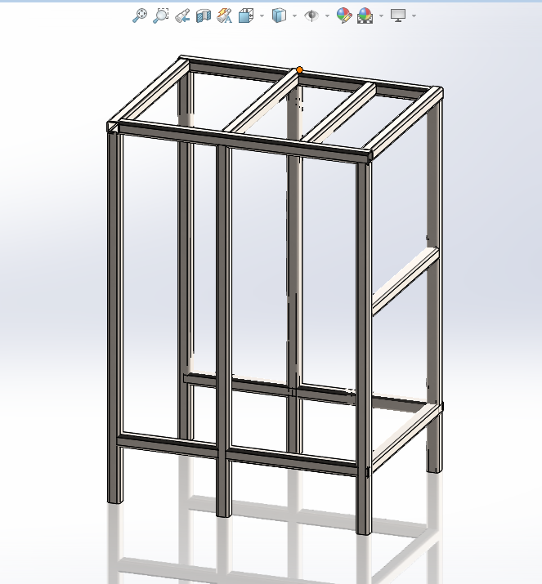

Figure (1): 3D Model of the Frame

4. Material Selection
The selected material for the structure is AISI 304 stainless steel. This material was chosen due to its good mechanical strength, corrosion resistance, and suitability for industrial environments.

Table 2. Material Properties

Property | Value
Material | AISI 304
Model type | Linear elastic isotropic
Yield strength | 2.068 × 10^8 $N$ / $m^2$
Tensile strength | 5.170 × 10^8 $N$ / $m^2$
Elastic modulus | 1.9 × 10^11 $N$ / $m^2$
Poisson’s ratio | 0.29
Density | 8000 kg/m³
Shear modulus | 7.5 × 10^10 $N$ / $m^2$
Thermal expansion coefficient | 1.8 × 10^-5 /K

5. Assumptions
The following assumptions were adopted in the simulation:
- The structure behaves as a linear elastic body.
- The loading is static and time-independent.
- Welded joints are assumed to be perfectly bonded.
- Material properties are uniform throughout the structure.
- Thermal effects, vibration, and impact loads are neglected.
- The support conditions are ideal and fully fixed at the base.

6. Boundary Conditions and Loading
A downward force of 2000 N was applied on the upper part of the frame. The lower supports were fixed to simulate a rigid attachment to the ground or foundation.

Table 3. Loads and Fixtures

Item | Description
Applied load | 2000 N downward
Load direction | Negative Z-axis
Load location | Top plane / selected beams
Fixture type | Fixed geometry
Fixed entities | 6 joints at the base
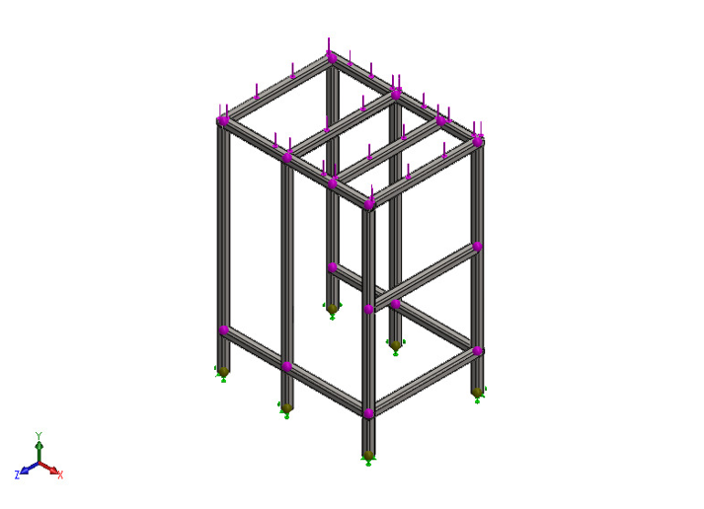
Figure (2): Applied Load and Fixed Supports

7. Finite Element Model
The analysis was performed using a beam-based finite element formulation. This approach is suitable for welded frame structures because it reduces computational cost while preserving the main structural behavior.

Table 4. Mesh Information

Item | Value
Mesh type | Beam mesh
Total nodes | 383
Total elements | 372
Solver type | Automatic
Large displacement | Off
Computation time | 00:00:01

8. Results and Discussion
The simulation provided the main structural response indicators: stress, displacement, reaction forces, and factor of safety.

8.1 Stress Analysis
The maximum von Mises-type beam stress reported by the simulation was 2.83 × 10^7 $N$ /$m^2$.
This value is significantly lower than the yield strength of AISI 304, which indicates that the frame remains in the elastic region under the applied load.
Figure (3): Von Mises stress distribution showing maximum stress concentration at the joints.
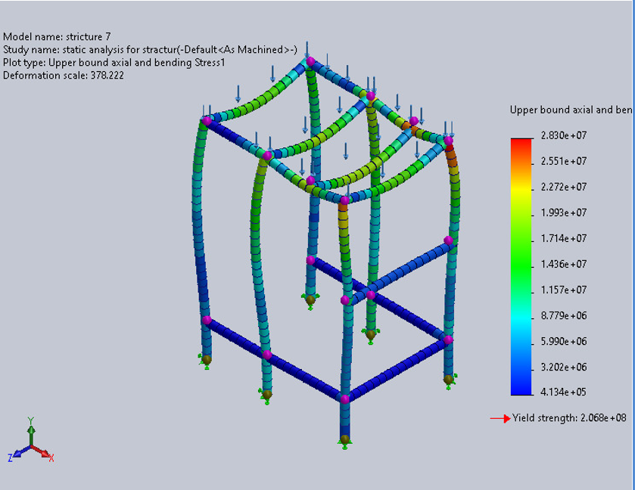

8.2 Displacement Analysis
The maximum resultant displacement was 0.3315 $mm$. This small value indicates that the frame has high stiffness and can maintain its shape under service loading.

8.3 Factor of Safety
The minimum factor of safety reported by the analysis was 7.308. This is a very safe value and indicates that the current design has a large safety margin.
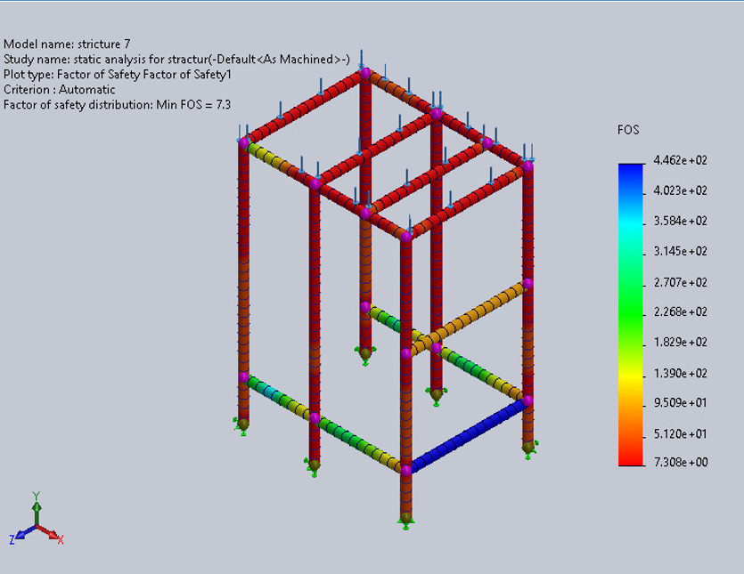
Figure (4): Factor of Safety Distribution

Table 5. Summary of Simulation Results
Result Item | Minimum | Maximum | Unit
Stress1 | 0.0 | 2.83 × 10^7 | $N$ / $m^2$
Displacement1 | 0.0 | 0.3315 | $$mm$$
Factor of Safety1 | 7.308 | 446.2 | —

Table 6. Key Structural Performance Indicators
Parameter | Value | Interpretation
Maximum stress | 2.83 × 10^7 $N$ / $m^2$ | Safe, below yield limit
Maximum displacement | 0.3315 $mm$ | Very small deformation
Minimum factor of safety | 7.308 | High safety margin

9. Reaction Forces
The model reaction forces show that the load is properly transferred through the support joints.

Table 7. Reaction Force Summary
Quantity | Sum X | Sum Y | Sum Z | Resultant
Reaction force | 3.8147 × 10^-6 $N$ | 14000 $N$ | 0 $N$ | 14000 $N$
Reaction moment | 1.06221 $N.m$ | 0.151968 $N.m$ | 2.5197 $N$. $m$ | 2.73866 $N.m$
The reaction forces confirm that the structure is balanced and that the load path is consistent with the applied boundary conditions.

10. Manual Validation
To validate the simulation, a simplified analytical stress calculation was performed.
The basic stress equation is:
$$σ=\frac{F}{A}σ= Stress MPa , F =Force N and A= Area m^2$$
Where:
- (F = 2000 $N$)
- (Area of Square Tube = 0.000534796 $m^2$)
Substituting the values:
$σ$ $=$ $\frac{2000N}{0.000534796m^2}≈3.74×{10}^{6}N/m^2$
The analytical value is approximately 3.74 MPa, while the simulation stress is 28.3 MPa.

Table 8. Validation Comparison
Method | Stress Value | Unit
Manual calculation | 3.74 × 10^6 | N/ $m^2$
SOLIDWORKS simulation | 2.83 × 10^7 | N/ $m^2$

Validation Discussion
The difference between the two values is expected because the manual calculation is a simplified axial-stress estimate, while the simulation accounts for the full structural behavior, including bending, load redistribution, and joint effects. Therefore, the simulation result is more representative of the actual frame behavior. The agreement in trend and the engineering consistency of the results confirm that the model is valid.

11. Design Evaluation
The results show that the frame is structurally safe, but the factor of safety is relatively high. This means that the design may be heavier than necessary for the applied load.
From an engineering point of view, the design can be optimized to reduce material usage and manufacturing cost without compromising safety.

12. Proposed Design Improvements
Based on the simulation results, the following improvements are recommended:
- Reduce tube thickness from 4 mm to 3 mm and recheck the results.
- Remove unnecessary members in low-stress regions if structural stiffness remains acceptable.
- Compare the original and modified designs in terms of weight, stress, and safety factor.
- Perform a second simulation after optimization to confirm that the minimum factor of safety remains above the acceptable threshold.

Table 9. Suggested Optimization Plan
Item | Original Design | Proposed Improvement
Tube thickness | 4 mm | 3 mm
Weight | Higher | Lower
Safety factor | 7.308 minimum | Target > 3
Material use | High | Reduced
Cost | Higher | Lower

13. Conclusion
The static analysis confirms that the welded mechanical frame is safe under the applied load of 2000 N. The maximum stress is well below the material yield strength, the displacement is very small, and the minimum factor of safety is high. These results indicate that the current design is structurally sound and suitable for industrial use.
However, the high safety factor suggests that the structure may be over-designed. Therefore, optimization is recommended to reduce material usage and cost while preserving safe operation.

14. Recommendations for Future Work
For a more complete engineering study, the following work is recommended:
- Perform dynamic or vibration analysis.
- Study the effect of different load positions.
- Evaluate weld strength separately.
- Manufacture a prototype and test it experimentally.
- Re-run the simulation after design optimization.

15. Final Statement
This report demonstrates the design, analysis, validation, and improvement strategy for a welded mechanical support frame. The analysis results confirm that the frame is safe, stiff, and suitable for its intended function, while also offering room for optimization.

